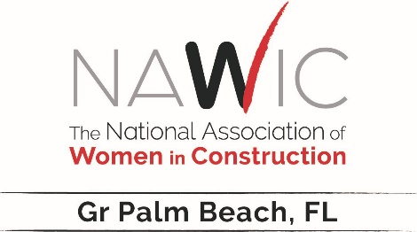
NAWIC CHAPTER #87
Greater Palm Beach
www.nawicpalmbeach.org

Amanda McGinley- Gr Palm Beach Ch87 President Report
Greater Palm Beach Ch 87 is so honored to host the NAWIC Fall Conference this year. We had a committee that went above and beyond trying to ensure this conference is a success to our Southeast region members. I am honored to be chapter president of this amazing group of ladies working hard in the industry so we can add growth and possibilities to the next group of women coming up behind us.
We hope to bring our chapter members more meaningful network opportunities that will cultivate their special attributes and highlight their achievements. I will continue to work towards getting the NAWIC name and core purpose out to all working in the industry. If this next year brings more trials and tribulations, we will work together to turn all obstacles into opportunities for empowerment and personal growth. With this team of chapter members, I look forward to having another wonderful year with all these women in my corner. Our recently installed board of directors is a dynamite group of hard working and ambitious women in the industry who will no doubt rocket us through another year of engaging chapter events and empowerment to all our members and guests.

